Adicionando nova rota

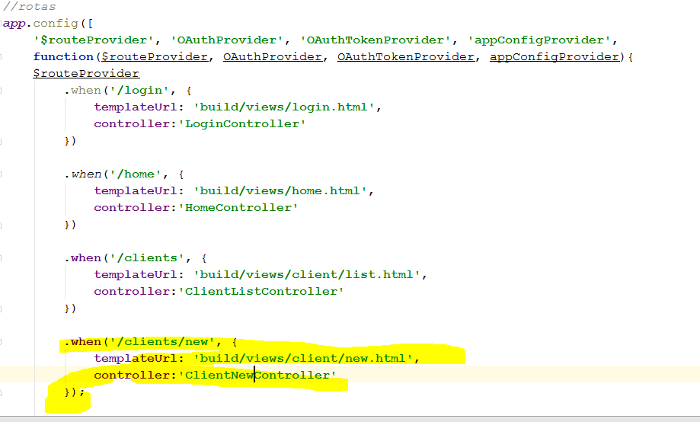

Criando COntroller e View

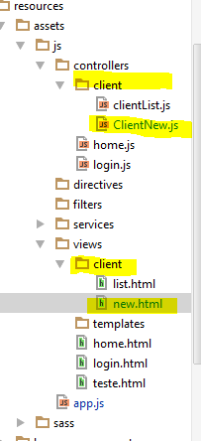

ClientNew.Js

**angular**.module(**'app.controllers'**)  
 .controller(**'ClientNewController'**, [**'$scope'**, **'$location'**, **'Client'**, **function** ($scope, $location, Client) {  
 $scope.**client** = **new** Client();  
  
 $scope.save = **function**() {  
 $scope.**client**.$save().then(**function**(){  
 $location.path(**'/clients'**);  
 });  
 }  
 }  
 ]);

New.Html

<**div class="container-fluid"**>  
 <**div class="row"**>  
 <**div class="col-md-8 col-md-offset-2"**>  
 <**div class="panel panel-default"**>  
 <**div class="panel-heading"**>Cadastro de Client</**div**>  
 <**div class="panel-body"**>  
 <**form class="form-horizontal" name="form" role="form" method="POST" ng-submit="save()"**>  
  
 <**div class="form-group" ng-class="{'has-error': !form.name.$valid && form.name.$touched}"**>  
 <**label class="col-md-4 control-label"**>Name</**label**>  
 <**div class="col-md-6"**>  
 <**input type="text" class="form-control" name="name" ng-model="client.name" required**>  
 <**div ng-messages="form.name.$error" class="help-block" ng-show="form.name.$touched"**>  
 <**div ng-message="required"**>Campo obrigatório!!</**div**>  
 </**div**>  
 </**div**>  
 </**div**>  
  
 <**div class="form-group"**>  
 <**div class="col-md-6 col-md-offset-4"**>  
 <**button type="submit" class="btn btn-primary"**>Cadastrar</**button**>  
 </**div**>  
 </**div**>  
 </**form**>  
 </**div**>  
 </**div**>  
 </**div**>  
 </**div**>  
</**div**>

App.bade

<**ul class="nav navbar-nav"**>  
 <**li**><**a href="**{{ url(**'#/home'**) }}**"**>Welcome</**a**></**li**>  
 <**li**><**a href="**{{ url(**'#/clients'**) }}**"**>List Clients</**a**></**li**>  
 <**li**><**a href="**{{ url(**'#/clients/new'**) }}**"**>New Client</**a**></**li**>  
</**ul**>

*<!-- CONTROLLERS !-->*<**script src="**{{ asset(**'build/js/controllers/login.js'**) }}**"**></**script**>  
<**script src="**{{ asset(**'build/js/controllers/home.js'**) }}**"**></**script**>  
<**script src="**{{ asset(**'build/js/controllers/client/clientList.js'**) }}**"**></**script**>  
<**script src="**{{ asset(**'build/js/controllers/client/clientNew.js'**) }}**"**></**script**>